Normalisation and ER Diagram

Matric: 40087220

Module: Database Systems

Coursework

Calls Normalisation:

Calls(Data)

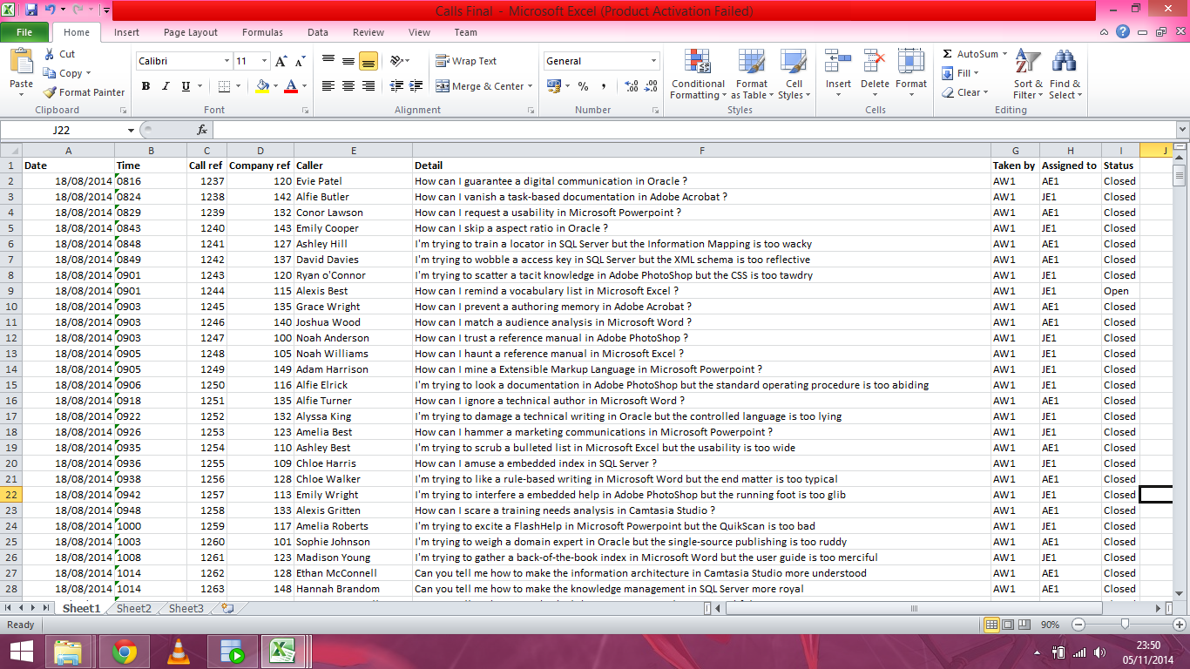

Calls(UNF, 1NF & 2NF)

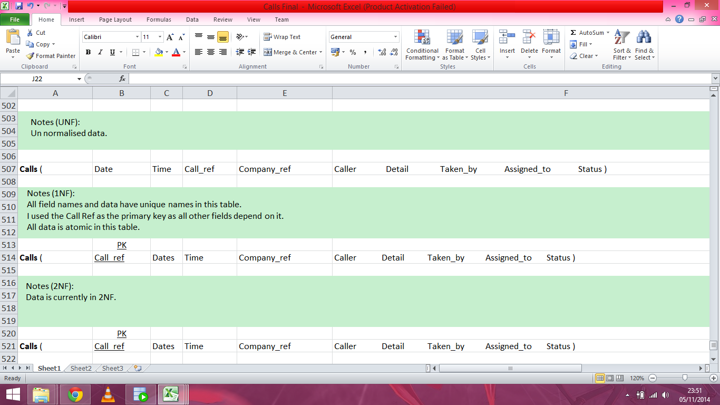

Calls(3NF)

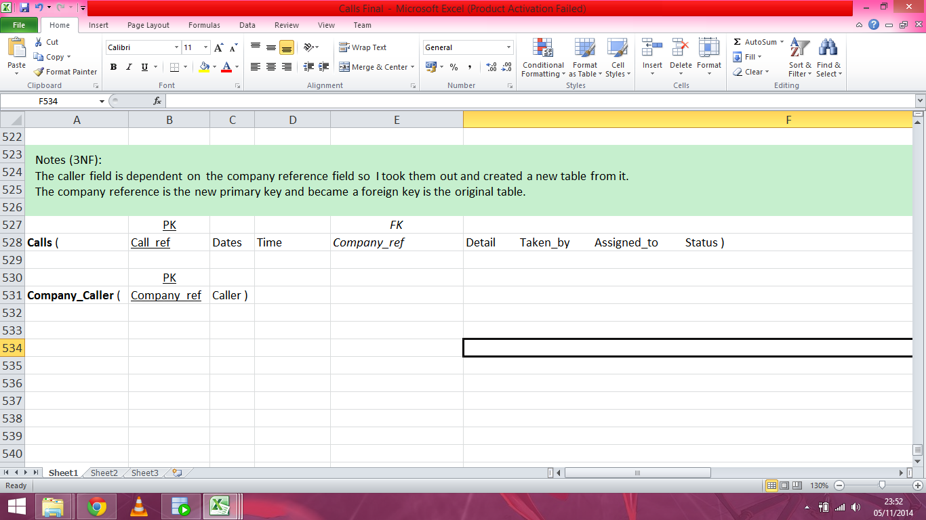

Customers Normalisation:

Customers(Data)

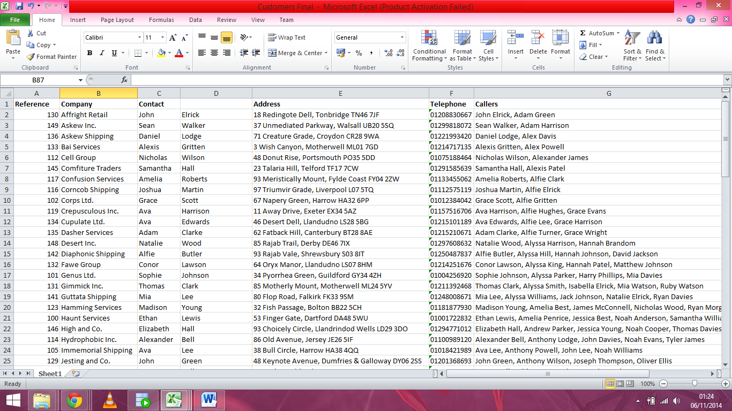

Customers(UNF & 1NF)

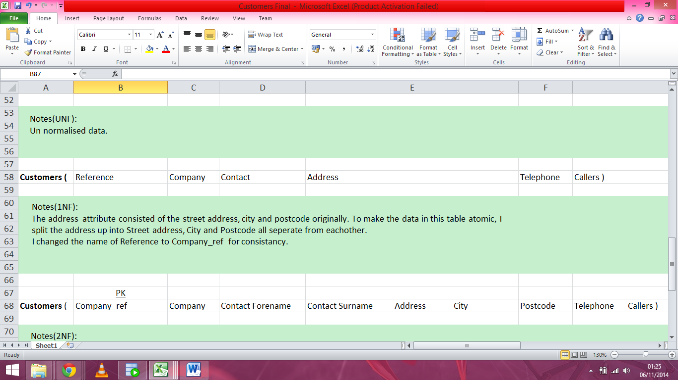

Customers(2NF & 3NF)

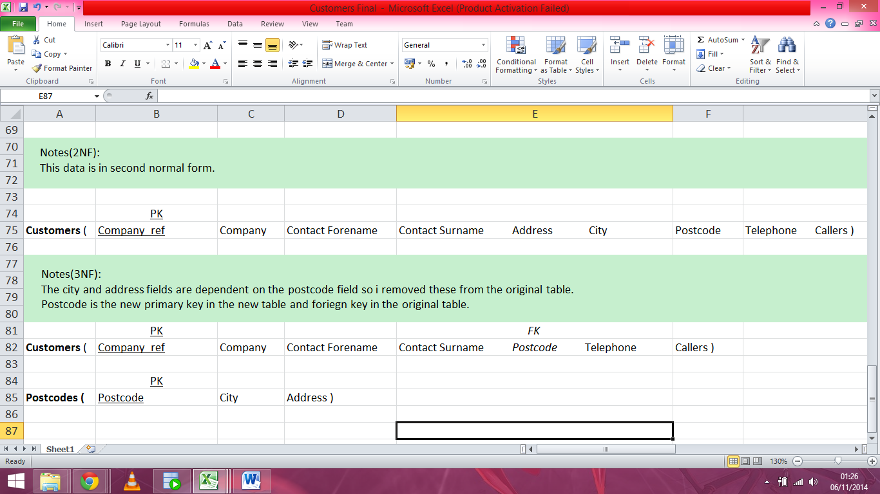

Shifts Normalisation:

Shifts(Data & UNF)

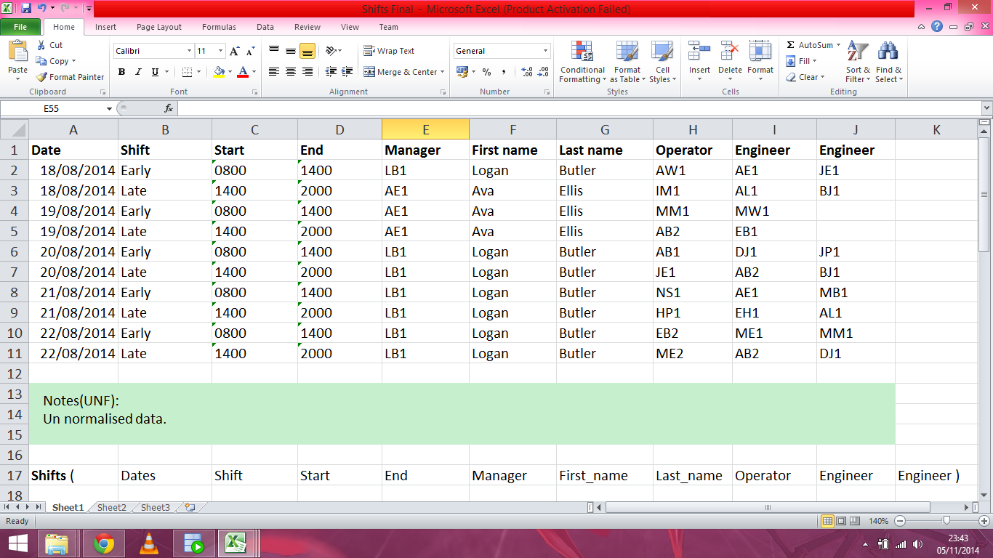

Shifts(1NF & 2NF)

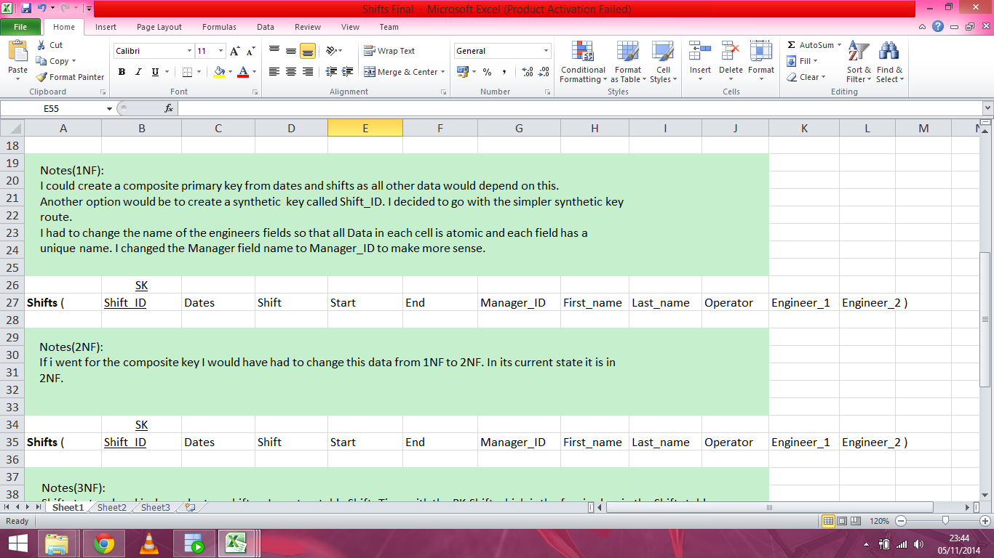

Shifts(3NF)

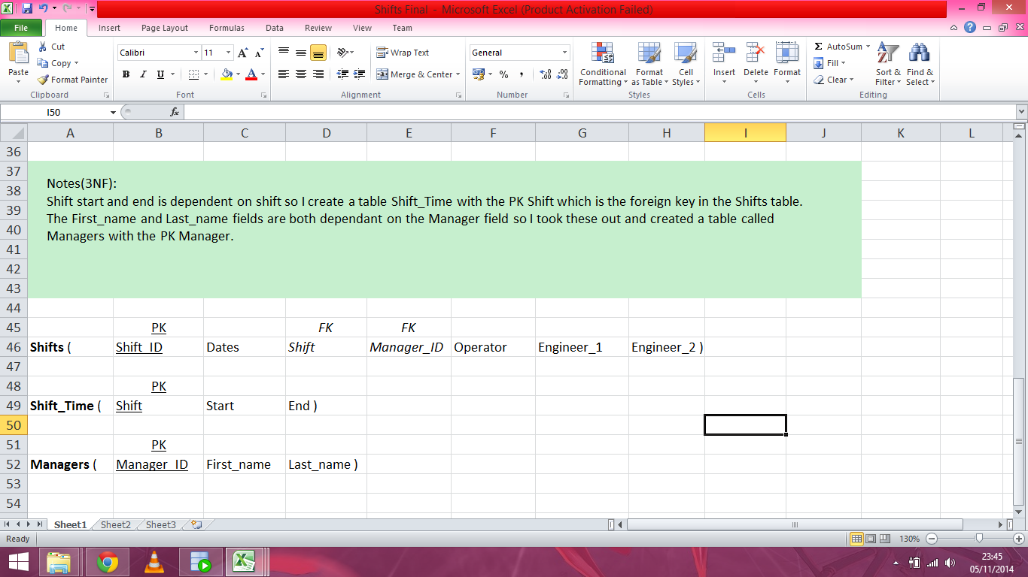

Staff Normalisation:

Staff(Data)

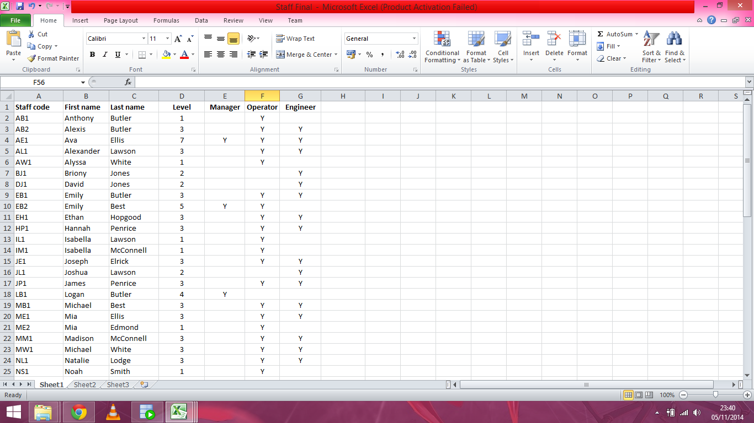

Staff(UNF & 1NF)

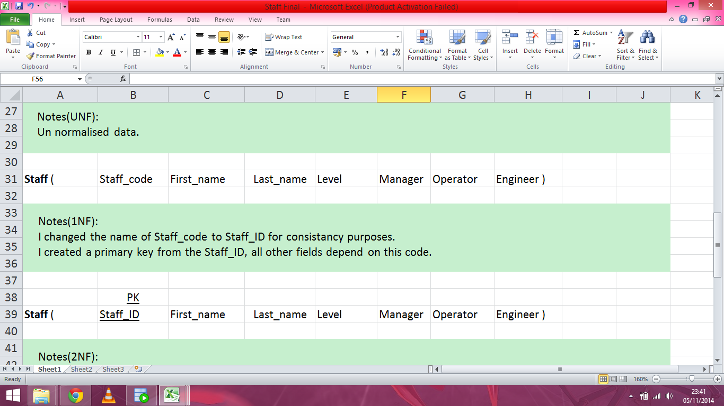

Staff(2NF & 3NF)

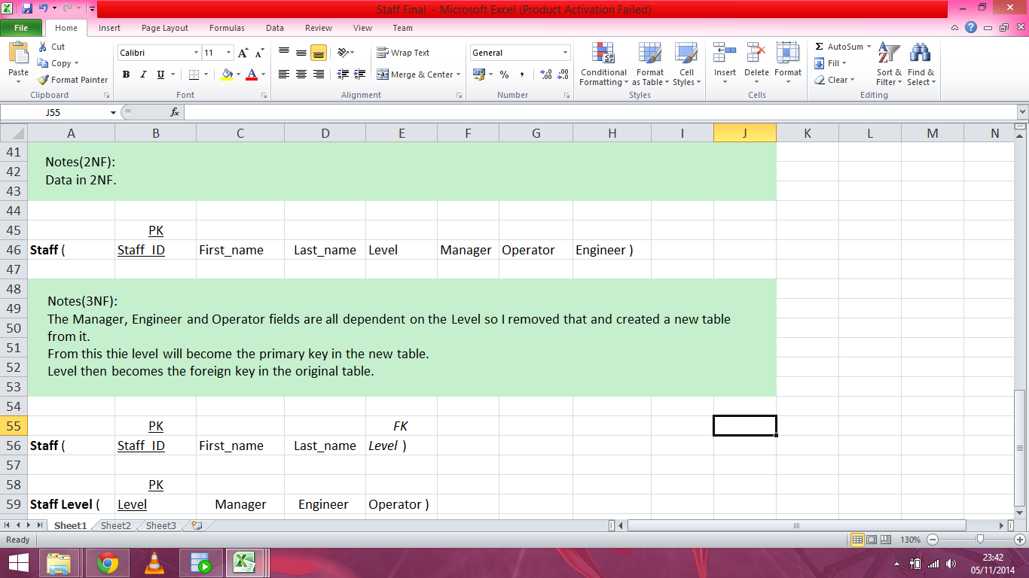

ER Diagram

